Belly-Busting Restaurant Meals

Marvel at America’s Highest-Calorie Restaurant Dishes – and Learn How to Eat Out Without Packing on Pounds
By Diane Wedner, Lifescript Health Writer
Published March 20, 2015
Reviewed by Edward C. Geehr, M.D., Lifescript Chief Medical Officer

Did you make a New Year’s resolution to cut down on calories and eat healthier meals? If so, you’ll want to be extra-careful when dining out. Here are the worst belly-busters to avoid in chain restaurants, along with nutritionists’ advice on tasty dishes you can order instead…
You probably know that restaurant meals are often higher in calories, fat and sodium than dishes you prepare yourself. But many diners are still surprised by the enormous servings and unhealthful ingredients available in some food chains.
Would you believe there’s a single serving of French toast with 2,780-calories – enough for a family of five? Or that you can order a crab dinner with enough calories to keep you fed for two days?
That’s what the Center for Science in the Public Interest (CSPI), a nonprofit health watchdog group in Washington, D.C., found when it researched the winners of its Xtreme Eating awards last summer.
“We saw some of the worst meals ever,” says Paige Einstein, R.D., a dietitian at CSPI. “People have no idea how bad these foods are.”
At many chain restaurants, it’s easy to consume more than a day’s worth of food in a single meal, Einstein says.
“You can expect 1,000 calories in any appetizer, entrée or dessert,” she notes. “If you get all three, you’re overloading.”
Why do customers keep ordering these enormous meals?
“Because people love the cheap prices at these restaurants and the fat, sugar and salt in the dishes,” says Katherine Talmadge, R.D., a Lifescript nutrition expert. “Humans are designed to go after high-calorie foods.”
What we don’t like are the results, Talmadge says.
“Being overweight is the worst thing you can do to your health,” she warns.
Fortunately, many restaurants now offer healthier dishes that don’t leave you waddling out the door, according to the National Restaurant Association, the nation’s largest food-service trade group.
“Consumers’ interest in nutritious options continues to grow and the industry continues to meet that demand by providing an array of healthful menu choices,” according to Joy Dubost, Ph.D., R.D., the association’s Senior Director of Nutrition and Healthy Living.
For example, the Cheesecake Factory, which has long been chided by the CSPI for its high-calorie meals, now provides a “SkinnyLicious” menu of lighter dishes with healthful ingredients.
How do you know if a meal is relatively healthful or a belly-bulging monster?
As a general rule, adults should consume no more than 2,000 calories, 20 grams of saturated fat and 1,500 mg of sodium in a day, according to the Dietary Guidelines for Americans. Women should take in no more than 6 teaspoons, or 25 grams, of added sugars.
But with the CSPI’s Xtreme Eating award “winners,” you can easily exceed that amount in a single sitting. Take a look at these monster meals so you know what not to order – and then learn about smarter alternatives. (Note: Some of the nutrition counts may have changed since the CSPI’s report was compiled.)

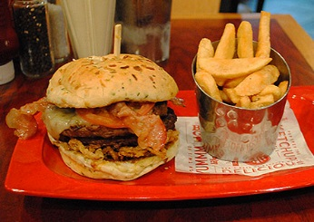

Belly-busting meal #1: “Monster” burger
The A.1. Peppercorn “monster”-size burger at Red Robin piles two beef patties, cheese, bacon, sauce, fried onions and bread on a single 1,670-calorie sandwich. It’s served with Bottomless Steak Fries – you “can eat as many as you want,” the menu boasts. Wash it all down with a Monster Salted Caramel Milkshake and you’ve consumed as much in one meal as you should in two days.
The health toll: The whole shebang totals a mind-boggling 3,540 calories. That includes 3 days’ worth of saturated fat (69 grams) and a 4-day supply of sodium (6,280 milligrams). Add to that ¾ cup of sugar – it's like eating 7 McDonald’s Double Cheeseburgers with a quart of Coke, the CSPI notes. You could work off the calories by taking a brisk walk – for 12 hours.
What to order instead: Red Robin’s single-patty veggie or chicken burgers, without the fatty onion rings and sauce, are “much better for you,” Epstein says. You can substitute a side salad, broccoli or coleslaw for the fries at no extra charge.

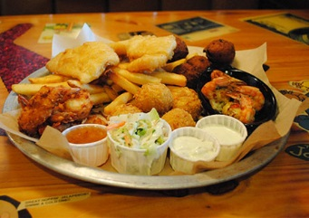

Belly-busting meal #2: Reel Big Catch
We couldn’t find the Big Hook Up Platter (pictured above) on the current menu at Joe’s Crab Shack. But you can still order the Reel Big Catch, a similar fried-food fiesta packed with breadcrumb-coated crab balls cream cheese served with ranch dressing, beer-battered chicken strips and fish fillets, coconut-fried jumbo shrimp, crab-stuffed fried shrimp; hushpuppies, fries, onion strings and coleslaw.
The health toll: The CSPI counted 3,280 calories, 50 g of saturated fat and 7,610 mg of sodium (a 5-day allotment). Burning off these calories would require 11 straight hours on the golf course without a cart or caddie.
“This is the worst seafood platter we’ve ever seen,” Epstein notes.
What to order instead: “If you crave fish, go to a seafood restaurant and order steamed, broiled or baked fish,” Epstein says.

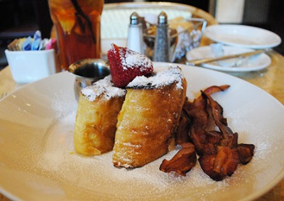

Belly-busting meal #3: Bruléed French Toast
The Cheesecake Factory’s Bruléed French Toast is not for the faint of heart. This breakfast extravaganza is stuffed with 1/4 cup of butter-infused syrup, and can be ordered with a side of bacon or ham. That’s equivalent to eating 14 slices of Aunt Jemima Frozen Homestyle French Toast stuffed with 2½ tubs of Kraft Philadelphia Original Cream Cheese Spread, according to the CSPI.
The health toll: This morning mega-meal weighs in at 2,780 calories, 93 g of saturated fat (about 5 days’ worth) and 2,230 mg of sodium. Don’t forget the 24 teaspoons of sugar.
“Nobody expects diet food at the Cheesecake Factory, but almost 3,000 calories for breakfast?” Einstein says.
What to order instead: Try an omelet with peppers, mushrooms, tomatoes and onions.

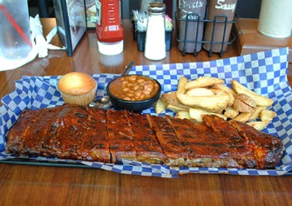

Belly-busting meal #4: Big Slab
Famous Dave’s Big Slab is a weighty piece of pork. Prepare your stomach for 1-1/2 pounds of spareribs (after the bones are removed), “slathered with sauce.” You get two sides plus a cornbread muffin. Choose the fries and baked beans and you pack more than an entire day’s calories into one dish.
Working off the calories from this meal would require using an old-fashioned lawnmower for 7½ hours straight, the CSPI says.
The health toll: This meal totals 2,770 calories (more than a day’s worth), 54 g of saturated fat, 4,320 mg of sodium and 14 teaspoons of sugar.
What to order instead: If you’re splurging on barbecue, get a single order, which is about 1/4 the size of this behemoth.
Or if you want a platter, “share that meal with a couple of people,” nutrition expert Talmadge suggests.

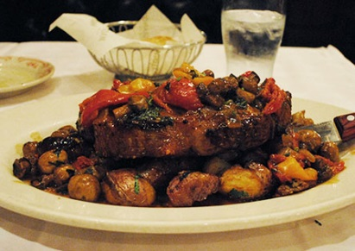

Belly-busting meal #5: Prime New York Steak Contadina-Style
Prime New York Steak at Maggiano’s Little Italy racks up 1,250 calories from the beef alone, the same as downing five McDonald’s Quarter Pounder beef patties, the CSPI notes. “Contadina-style” means you also get two Italian sausages, crispy potatoes, roasted red and yellow peppers, mushrooms, caramelized onions, sun-dried tomatoes, steak gravy and garlic butter, which adds enough calories for four more Quarter Pounders plus a cheeseburger.
The health toll: It’s just meat and veggies, but you’re looking at 2,420 calories, plus 66 g of saturated fat (more than 3 days’ worth) and 5,620 mg of sodium (ditto). You’ll have to hit the rowing machine for 7½ hours to burn this one off, the CSPI says.
What to order instead: “If you crave steak, pick the smallest size they offer and get [leaner cuts such as] sirloin or filet mignon,” Epstein recommends. “And skip the sausage topping!”

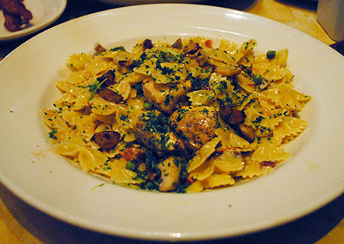
Belly-busting meal #6: Farfalle With Chicken
The Cheesecake Factory “wins” again with its Farfalle with Chicken and Roasted Garlic dish. It doesn’t sound like a calorie bomb, but eating this pasta meal is equivalent to polishing off five single-serve packages of Stouffer’s frozen Classics Chicken Fettuccini Alfredo, each topped with butter.
The health toll: The large portion and creamy sauce add up to 2,410 calories, 63 g of saturated fat (3 days’ worth) and 1,370 mg of sodium. You’ll need a 5-hour jog to burn off this one.
What to order instead: “If you’re ordering pasta, opt for whole-grain noodles and a tomato-based sauce,” Epstein suggests. “And choose vegetables, chicken or seafood instead of meatballs.”

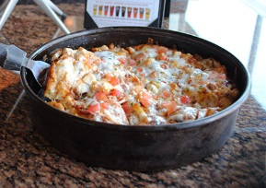

Belly-busting meal #7: Deep-Dish Chicken Bacon Ranch Pizza
BJ’s Signature Deep Dish Chicken Bacon Ranch 9-inch Pizzamay be small in diameter, but it’s calorically similar to three Pizza Hut Personal Pan Pepperoni Pizzas, the CSPI says. Thank the bacon, jack and cheddar cheeses, along with ranch dressing.
The health toll: This feast has 2,160 calories, 30 g of saturated fat and 4,680 mg of sodium (3 days’ worth). Erasing this meal would require 5-1/2 hours of nonstop bicycling, the CSPI says.
What to order instead: For a healthier pizza, “go with with a whole-grain crust instead of deep-dish, which absorbs more oil from the melted cheese,” Epstein says. “Top it with vegetables or seafood; skip the salami and other meats.”

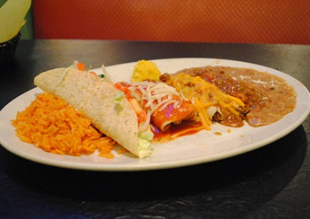

Belly-busting meal #8: Super Cinco Combo
Combo meals at Mexican restaurants can include a lot of food – but when it comes to the Super Cinco Combo at Chevys Fresh Mex, that’s an understatement. You get two enchiladas, a beef taco, hand-rolled pork tamale and chile relleno. But that’s not all. This dish also comes with rice and a choice of beans, including refried made with bacon.
It’s as much food as 11 Taco Bell Crunch Tacos, the CSPI says.
The health toll: This big boy delivers 1,920 calories, 36 grams of saturated fat and 3,950 mg of sodium (more than 2 days’ worth). That’s not counting the basket of chips you’re given to snack on before the main course. Plan on 3½ hours of singles tennis to work off this baby.
What to order instead: “Have one or two fish or chicken tacos or enchiladas,” Epstein says. “Definitely hold the chips, and eat black beans instead of the refried ones.”

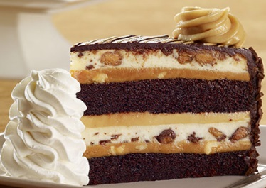

Belly-busting meal #9: Peanut Butter Chocolate Cake Cheesecake
Here we are back at the Cheesecake Factory, which is as famous for desserts as for main courses – but whose Reese’s Peanut Butter Chocolate Cake Cheesecake is like having three desserts in one. To undo this calorie cluster, you’ll need to sweat through 4-1/2 hours of aerobics, the CSPI warns.
The health toll: You’re staring down 1,500 calories, 43 g of saturated fat and 21 tablespoons of mostly added sugar. It’s like eating an entire four-serving Sara Lee Classic Original Cream Cheesecake, topped with a cup of Breyers Chocolate Ice Cream.
What to get instead: Choose a bowl of fresh strawberries instead of a sugary dessert, Epstein suggests. Or if you can’t resist something sweeter, remember that a “regular” Cheesecake factory dessert is 800 calories, so split one among your entire party.

Belly-buster antidotes
Americans are dining out more often, which means you could find yourself in a chain restaurant sometime soon. If you do, follow these tips for an enjoyable meal that doesn’t leave you waddling home:
- Check the nutrition data. Some restaurant dishes have far more calories than you expect – so be an informed eater. Federal law will soon require more than 250,000 chain restaurant locations across the country to provide nutrition information to consumers at the point of purchase, the National Restaurant Association’s Dubost said in a statement. In the meantime, many restaurants now publish their offerings' nutritional information online.

- Skip the beef, bun and fries. Instead of bottomless fries, ask for bottomless veggies, recommends the CSPI. Grab a chicken or garden burger and go bunless. Or get the beef burger wrapped in lettuce, now a common option at many restaurants.

- Try the “skinny” menu. Restaurants have come a long way since the days of the cottage cheese “diet plate.” Many have answered the call for lower-calorie meals by providing lightened-up dishes that still taste good.

- Lighten your pizza. Ask for less cheese and order a thin crust.

- Say adios to chips and combos. At Mexican restaurants, skip the chips (don’t even allow them on your table), the CSPI suggests. Ditto for refried beans.

- Hold the appetizers and desserts. Restaurant entrées are filling enough – so avoid these extras, which are often jammed with 1,000-plus calories, Epstein says.

- Share an entrée, or take half of it home. That way you can ease up on calories without feeling wasteful, Epstein says.

- Don’t overdo the alcohol. One glass of wine has 150 calories, and a glass of beer has 200, Epstein says.
For more information and expert advice, visit Lifescript’s Obesity Health Center.

